

[**chippenhamny@gmail.com**](mailto:chippenhamny@gmail.com)

**Facebook: chippenhamnetballyouth**

**Twitter: @chippenhamnetb1**

**Chippenham Youth**

**Netball Club**

**U8-U13**

**Years 3-8**

**Membership Pack**

**2020/2021**

**Welcome to Chippenham Youth Netball Club**

**2020/21 Season**

**NB Training for the first term will be 45 minute sessions**

**Mondays Time Coach**

Under 9s (Year 3/4) 3.30 – 4.15 Pam Murnan

Under 10s (Year 5) 4.30 – 5.15 Pam Murnan

Under 12s (Year 7) 4.30 – 5.15 Sharon Sanders/Selina Porter

Under 11s (Year 6) 5.30 – 6.15 Sharon Sanders/Selina Porter

**Tuesdays**

Under 13s (Year 8) 5.00 – 5.45 Selina Porter

**2020/21 Training Dates**

14/09/2020 – 07/12/2020 excluding 26/10/2020

11/01/2021 – 29/03/2021 excluding 15/02/2021

19/04/2021 – 28/06/2021 excluding 03/05/2021 and 31/05/2021

**NB If you cannot train, please contact your coach via whatsapp in advance**

**We have a waiting list, if we feel that your daughter’s attendance is irregular you may be asked to reconsider your membership.**

**We are only responsible for your child inside the dome during training times.**

**Please drop and collect your daughter in (outside for term 1) the dome.**

**Dropping and collecting your daughter from the carpark is at your own risk.**

**Location**

Chippenham Air Dome at Chippenham Sports Club, Bristol Road, Chippenham, SN15 1NG

**Annual Fees**

**£120 for existing members (reduced 19/20 season) £160 new members**

Included within your annual membership fees are your affiliation payments to England Netball. Without this you are unable to play netball.

Also included is payment to become a member of Chippenham Sports Club. If you are already a member with another section please let us know.

**How much and when to pay**

|  |  |  |  |  |  |
| --- | --- | --- | --- | --- | --- |
| **U13s (Year 3 – 8)** | | | | | |
| **How much?** | |  | **Payment options** | | |
|  |  |  | Full payment | £120/160.00 | payable by 28/9/20 |
|  |  |  | **OR** |  |  |
| Full payment for year | **£120 existing**  **£160 new** |  | Payment 1  Payment 2 | £60/80.00  £60/80.00 | payable by 28/9/2020  payable by 28/2/2021 |

**If you have a concern with payment, please see a member of the committee.**

**Methods of Payment**

Payments should be made to:

**Chippenham Youth Netball Club**

**Lloyds bank**

**Account Number: 66253468 Sort code: 30-91-99**

Please give your **child’s full name** as a reference for you individually so we can confirm payments.

Alternatively you can pay by cheque, made payable to Chippenham Youth Netball Club or by cash.

**Friendly matches in Devizes/Chippenham (tbc)**

Under 13s (years 6-8)

**League matches (y6-8) (tbc)**

**Coaches will select teams for the competitive Swindon league based on ability. Not all players will play in these matches. Team players will need to purchase club dresses.**

**All players will have the opportunity to play intra-club matches at their training sessions.**

**Swindon league venue**

Dorcan dome, St Pauls Drive, Swindon, SN3 5DA

**Kit**

If you are playing in a league match, you must wear a Chippenham Netball dress. This can be purchased from <http://www.sportingbilly.com/c-jl/club-shops/chippenham-netball-club.htm>

Address: Unit 10 Bath Rd Ind. Estate, Chippenham, SN14 OAB

Training kit is also available but not essential.

**Other Information**

All players are encouraged to develop their skills further including coaching and umpiring

All new members will be accompanied by an existing member at their initial training sessions.

No jewellery to be worn to training, nails need to be kept short and hair up at all times.

Please avoid ear piercing during netball season (September-June)

No (visible) mobile phones please.

**Contact Information:**

Chairperson Selina Porter

Treasurer Pam Murnan

Safeguarding Officer/covid officer Selina Porter

Administration/membership Sharon Sanders

Coaches Pam Murnan, Sharon Sanders, Selina Porter

# 

# Codes of Conduct for all Volunteers and Paid Coaches participating in Netball Activity with u18s, including:

As a Chippenham Netball Youth coach/umpire I will Respect:

1. The rights, dignity and worth of Children, Young People and Adults at Risk and ensure that I am aware of the Safeguarding Policies and best practice guidelines and procedures when interacting with them.
2. The rules, regulations and requirements of netball, including, but not limited to, any competitions in which I participate either directly or indirectly
3. The rights, dignity and worth of all people involved in netball, regardless of gender, marital status, race, colour, disability, sexuality, age, occupation, religion or political opinion
4. Confidentiality and the sensitivities of information I hold on other individuals.
5. Netball and the individual’s reputation and not take any action or make inappropriate comments about a fellow coach, official, volunteer or member of England Netball’s staff that will bring the Sport or those associated with delivering the Sport into disrepute, and I will respect EN’s guidance and policies on safeguarding and social media technology.

I will:

1. Ensure the safety of all children and young people by providing effective supervision, proper pre-planning of coaching sessions in line with their abilities, and use safe methods at all times.
2. Establish and address the additional needs of disabled participants or other vulnerable groups.
3. Inspire and motivate each individual to enable them to play to the best of their abilities regardless of any disability, sickness or injury. Appreciate their efforts, and not over-train them.
4. Treat all young people fairly, give them equal attention and opportunities, ensure they feel valued, and have no favourites.
5. Take time to explain coaching techniques to ensure they are clearly understood. Develop an appropriate working relationship with participants, based on mutual trust and respect.
6. Consider the wellbeing and safety of participants before the development of performance
7. Encourage and guide participants to accept responsibility for their own performance and behaviour.
8. Never exert undue influence over high performers to obtain personal benefit or reward.
9. Be positive, approachable, respect and listen to their opinions, and offer praise to promote the objectives of the club at all times.
10. Always report any disclosure made to me, or allegations of abuse or poor practice in line with the club’s and England Netball’s procedures.
11. Have access to telephone for immediate contact to emergency services if required. Develop team work to ensure the safety of youth members in my care.
12. Never engage in a sexual relationship with a young person under 18 for whom I am responsible
13. Be a positive role model, displaying consistently high standards of behaviour and appearance (disciplined/ committed/time keeping), children learn by example.
14. Be mentally and physically fit to carry out my role within netball
15. Hold appropriate, current, valid qualifications, safeguarding training and insurance cover and other personal and professional development opportunities.
16. Refrain from smoking and consumption of alcohol during club activities or coaching sessions.
17. Never condone rule violations, rough play, inappropriate language or the use of prohibited substances
18. Not allow any rough or dangerous play, bullying, use of bad language or inappropriate behaviour.
19. Discourage all discrimination on the grounds of religious beliefs, race, gender, social classes or lack of ability.
20. Never use sanctions that humiliate or harm young people.
21. Never spend excessive amounts of time alone with children unless there are exceptional circumstances
22. Never take children to their home
23. Never administer minor first aid involving the removal of children’s clothes only in the presence of others and where required refer more serious incidents to the club first aider.
24. Make netball fun.

I understand that the safety and welfare of young people is paramount and will endeavour to abide by these Code of Conduct and promote it to others.

I understand that if I fail to follow the Codes, then England Netball, the Regional Association or the County Association may take action against me under the Disciplinary Regulations or the Safeguarding Disciplinary Regulations which may result in Sanctions including fines and suspension.

………………………….………………………………..…….……. ………………………………………………………………………….. ……………………………….……..

Name (print) Signature Date

Code of Conduct for Parents/Carers 2020/21

The enjoyment and safety of your child when involved in a netball activity is of paramount importance to England Netball. Every child will be encouraged and asked to ensure that their behaviour and actions meet the values and standards expected of them at all times. As parents, you are asked to support our Codes of Conduct and embrace the spirit of our game.

As a parent/carer, I will:

1. Encourage my child to play within the rules and respect officials’ and coaches’ decisions
2. Support my child’s efforts and performance, give positive comments that motivate and encourage continued effort and learning
3. Understand that competition is about winning and losing, so results are always accepted without undue disappointment
4. Be a positive role model to my child by helping them work towards skill improvement and good sportsmanship
5. Remember that children learn best by example; I will applaud good play by both my child’s team and their opponents
6. Thank the coaches, officials and other volunteers who give their time for my child and not interfere with their decisions
7. Help when asked by a coach or official
8. Respect the rights, dignity and worth of all people involved in the game, regardless of gender, marital status, race, colour, disability, sexuality, age, occupation, religion or political opinion
9. Read the rules of the sport to understand better what I am watching and discussing with my child
10. Promote this code of conduct to other parents, carers and supporters
11. Be aware of my child’s club safeguarding policy and ensure that any concerns are reported to the club’s safeguarding officer or England Netball’s Lead Safeguarding Officer.

As a parent/carer, I will not:

1. Pressure my child in any way; I know that this is their sport not mine
2. Use inappropriate language, harass athletes, coaches, officials or other spectators
3. Criticise or ridicule my child for making a mistake or losing after the game
4. Force my child if they are unwilling to participate in the sport
5. Arrive at a netball activity under the influence of alcohol or drugs
6. Use Social Media technology to bring the game into disrepute or make an inappropriate comment about an athlete, coach, official, volunteer or member of England Netball staff
7. Consume illegal substances either immediately prior to or while being at a netball activity where my child is participating in the sport
8. Consume alcoholic drinks or smoke either immediately prior to or while being at a netball activity where my child is participating.

………………………….………………………………..…….……. ………………………………………………………………………….. ……………………………..

Parent/Carer Name (print) Signature Date

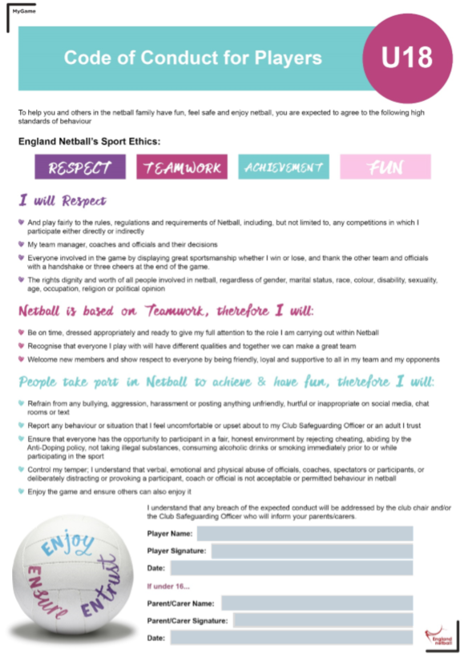

**How to register your child with ENGAND NETBALL ENGAGE**

Step 1 On the search bar type England Netball **Engage**

Step 2 Log Into your membership

Step 3 Click on access Engage

Step 4 Find club **YOUTH CHIPPENHAM** (not CHIPPENHAM)

Step 5 Register

ENA number ………………………… Paid Yes / No

**2020/21 Training Dates**

14/09/2019 – 07/12/2020 excluding 26/10/2020

11/01/2021 – 29/03/2021 excluding 15/02/2021

19/04/2021 – 28/06/2020 excluding 03/05/2020 and 31/05/2021

**NOTES**



**Checklist**

|  |  |
| --- | --- |
| Completed membership form | YES/NO |
| Enclosed payment | YES/NO |
| £120/160 due by 28/9/20 | YES/NO/ONLINE |
| £60/80.00 due by 28/9/20 | YES/NO/ONLINE |
| £60/80.00 due by 28/2/21 | YES/NO/ONLINE |
| I have read and signed code of conduct – Player | YES/NO |
| I have read and signed code of conduct – Parent | YES/NO |
| I give permission for my personal details to be used for the purposes of the club. Please put your initials in the box.  Please inform us if you do not wish for your personal details to be held by the club. |  |

**CAN YOU HELP?**

**We are extremely grateful for everyone who helps in whatever way they can. If you would be able to offer us some time please let us know. Listed are below are some of the ways you can help, tick and return with your daughter’s membership form and we will be in touch.**

**THANK YOU!!**

|  |  |
| --- | --- |
| Become a coach |  |
| Become an umpire |  |
| Volunteer to help at training sessions |  |
| Help on match days   * Scoring * Team manager | **Training will be given!!** |
| Newsletter writer |  |
| Bib and ball maintenance |  |
| Cupboard tidier |  |
| Join our committee |  |

**PLEASE RETURN THIS CHECKLIST WITH YOUR COMPLETED MEMBERSHIP FORM**